Polish Constructivism

Polish Constructivism, a long-lasting direction within INTERNATIONAL CONSTRUCTIVISM, had links to similar movements in Germany, Holland, Belgium, France and to the YIDDISH AVANT-GARDE, but was strongly connected to RUSSIAN CONSTRUCTIVISM because artists such as KATARZYNA KOBRO and Władysław Strzemiński began their careers in Russia and shared the Constructivists’ enthusiasm for the dynamics of modern life and concern with objectless geometric forms. The local origin of the movement lay in the formal experiments related to Formism (often interpreted as a Polish version of CUBISM) and FUTURISM, which in Poland were influenced by DADAISM and POLISH EXPRESSIONISM.

In the visual arts, Polish Constructivism was initiated at the 1921 Warsaw exhibition of assemblages made from wood, metal and glass by Władysław Szczuka, Edmund Miller and Henryk Stażewski. The catalogue of the 1923 Wystawa Nowej Sztuki (Exhibition of New Art) in Vilnius contained the first theoretical statements of the movement, formulated among others by TERESA ŻARNOWER. In 1924 Mieczysław Szczuka, Witold Kajruksztis/Vytautas Kairiukštis and Henryk Stażewski along with HENRYK BERLEWI founded the artist group and magazine Blok. Within the group, there was a significant division: While Strzemiński focused on the pure qualities of static painting as a field of formal experiments, Szczuka preferred the applied arts – modern typography, prints, and film. He and Żarnower focused on industrial advertisement, stage and architectural design – examples of which they showed at the International Exhibition of Modern Art in Bucharest and the International Exhibition of Modern Architecture in Warsaw in 1926.

Strzemiński and Kobro distanced themselves from the ‘productivist’ wing of the group already in 1924/25 and, in 1926, they joined together with Stażewski and the Praesens group (1926-29), founded by the architects Szymon Syrkus, Józef Szanajca, Stanisław Brukalski, Bohdan Lachert and others. In 1927 they established a link with Le Corbusier and organized Kazimir Malevich’s exhibition in Warsaw. The group’s architects exhibited their work at the Machine Age Exhibition in New York (1927) and created spectacular pavilions and interior designs at the 1929 Powszechna Wystawa Krajowa (Universal National Exhibition) in Poznań, an official show of the achievements of the young, independent Polish state.

Kobro and Strzemiński, who devoted themselves to the ‘laboratory’ of pure artistic expression, left the utilitarian oriented architects of Praesens and, together with the poets Julian Przyboś and Jan Brzękowski, created the group a.r. (‘revolutionary artists’/ ‘real avant-garde’, 1929-36). Strzemiński initiated the creation of an international collection of modern art. He was supported by Brzękowski and Stażewski, active in Paris who privately transported to Łódź 21 art pieces by representatives of Cercle et Carré and Abstraction-Création, among them Hans Arp, Max Ernst, Fernand Legér, Amédée Ozenfant, Pablo Picasso, Enrico Prampolini, Michel Seuphor, Theo van Doesburg and Georges Vantongerloo. By 1931 the collection had grown to 75 works of which only 15 were by Polish artists; the same year the Łódź Museum of Modern Art was opened, becoming one of the first permanent museum exhibitions of contemporary art and a symbol of the institutionalisation of the avant-garde.

Polish Constructivism was widely interconnected with the international avant-garde. Throughout the 1920s, art and the theoretical ideas by Herwarth Walden, Malevich, Filippo Tomaso Marinetti, Kurt Schwitters, and van Doesburg were presented in publications such as Blok (1924-26) and Zwrotnica (Railway Swith, 1922-24 and 1926-27). Tadeusz Peiper, the ‘pope of the avant-garde’ and author of the manifesto “Miasto. Masa. Maszyna” (City. Mass. Machine) cooperated e.g. with Tristan Tzara and Le Corbusier, while Brzękowski’s poetry volumes were illustrated with drawings by Arp and Ernst.

The ‘a.r.’ book collection and the two flyers Komunikat (1930+1932) aimed at presenting the history and theory of modern art. ‘a.r.’ cooperated with several periodicals, among them the bilingual journal L'Art Contemporain – Sztuka Nowoczesna (Modern Art, 1929-30), issued by Brzękowski and Wanda Chodasiewicz-Grabowska [Nadia Leger] in Paris, and the Polish literary magazines Linja (Line, 1931-33), Europa (1929-30) and Forma (1933-36). Strzemiński experimented with functional print (Druk funkcjonalny, 1935); his typography for Przyboś’ volume of poetry Z ponad (From beyond, 1930) is a significant example of the constructivist synergy of word and image.

Between 1932 and 1939 Łódź became a venue for international exhibitions of typography, including works by Marinetti, László Moholy-Nagy and Jan Tschichold. Photomontages and films with examples of propaganda posters, journals and books covers by Żarnower and Szczuka were also presented, among them covers for the volume of poetry Ziemia na Lewo (Earth to the left, 1924, written by Anatol Stern/Bruno Jasieński) and Europa (1927/1929, written by Stern). The photomontages by Kazimierz Podsadecki and Janusz Maria Brzeski were designed not for political publications but for popular mass media. Franciszka and Stefan Themersons’ photographic experiments resulted in surrealist collages which were used in the first Polish avant-garde film Europa.

A biocentric constructivist approach with theosophical influences and links to the metaphysical wing of the Bauhaus and the early Russian avant-garde can be found in Karol Hiller’s heliographic photographic experiments, Witold Krassowski’s stage designs, the late paintings of Bolesław Biegas and the work of the Berlin-based Stanisław Kubicki.

The last phase of Polish constructivism was characterized by a literary movement called Second Avant-garde which gathered around the groups and magazines Kwadryga (Quadriga, 1927-31) in Warsaw and Żagary (Brush-Wood, 1931-39) in Vilnius. Whereas the program of the first avant-garde in Cracow leaded by Peiper contained elements such as social engagement and intellectual discourses, the second avant-garde added its own specific component of visionary catastophism, which anticipated World War II.

References and further readings:

Timothy O. Benson and Éva Forgács (eds), Between Worlds: A Sourcebook of Central European Avant-Gardes, 1910-1930, Cambridge, Mass./London: The MIT Press, 2002.

Constructivism in Poland, 1923-1936: Blok, Praesens, a.r., Łódź: Museum of Art, Essen: Folkwang Museum, Otterlo: Rijksmuseum Kröller-Müller, 1973.

Stanisław Czekalski, Fotomontaż polski w XX-leciu międzywojennym, Warszawa: Zachęta Państwowa Galeria Sztuki, 2003.

Lidia Głuchowska, Avantgarde und Liebe. Margarete und Stanislaw Kubicki 1900/1945, Berlin: Gebr. Mann, 2007.

Jaromir Jedliński, The Museum Sztuki in Łódź: a Question of Modernity, Polnische Avantgarde, 1930-1990, Berlin: Neuer Berliner Kunstverein, 1992.

Andrei Nakov, Kazimierz Zdzichowski, Hiller –heliographs, London: Annely Juda Fine Art, 1982.

Piotr Piotrowski, ‘The Avant-Garde Institutionalised? The 1932 City of Łódź Art Prize Awarded to Władysław Strzemiński’, Uměni 3 (2003): 211-218.

Andrzej Turowski, Budowniczowie świata. Z dziejów radykalnego modernizmu, Kraków: Universitas, 2000.

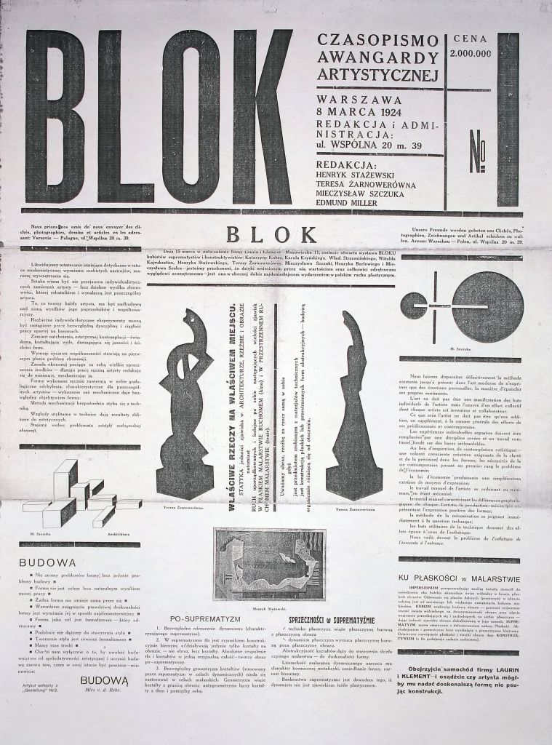
1. The cover of the first issue the Blok magazine, designed by Henryk Stażewski, Warsaw 1924, 60 x 45 cm,
photo: courtesy of Museum of Art, Łódź

http://www.culture.pl/web/english/resources-visual-arts-full-page/-/eo_event_asset_publisher/eAN5/content/blok-group

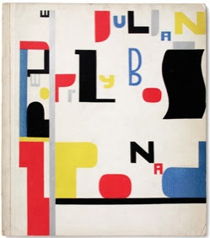
2. Władysław Strzemiński, the cover of the poetry volume by Julian Przyboś Z ponad (Sponad), Cieszyn : Zakłady Drukarskie i Wydawnicze Karola Prochaski, 1930.
http://2.bp.blogspot.com/-BXKE3gHboG4/TVmPIFV2FGI/AAAAAAAAEOE/WAV39i4FMW0/s400/145.jpg&ir=http://temple-of-light.blogspot.com/2011/02/wladyslaw-strzeminski-katarzyna-kobro.html&ig=http://t0.gstatic.com/images?q=tbn:ANd9GcTCKKIf4uP-Q-1MrBQEUecM663eYo-ahvZOAiEPwalbz8PZezmSvhA_Kg&h=282&w=249&q=strzeminski+wladyslaw&babsrc=TB_ss
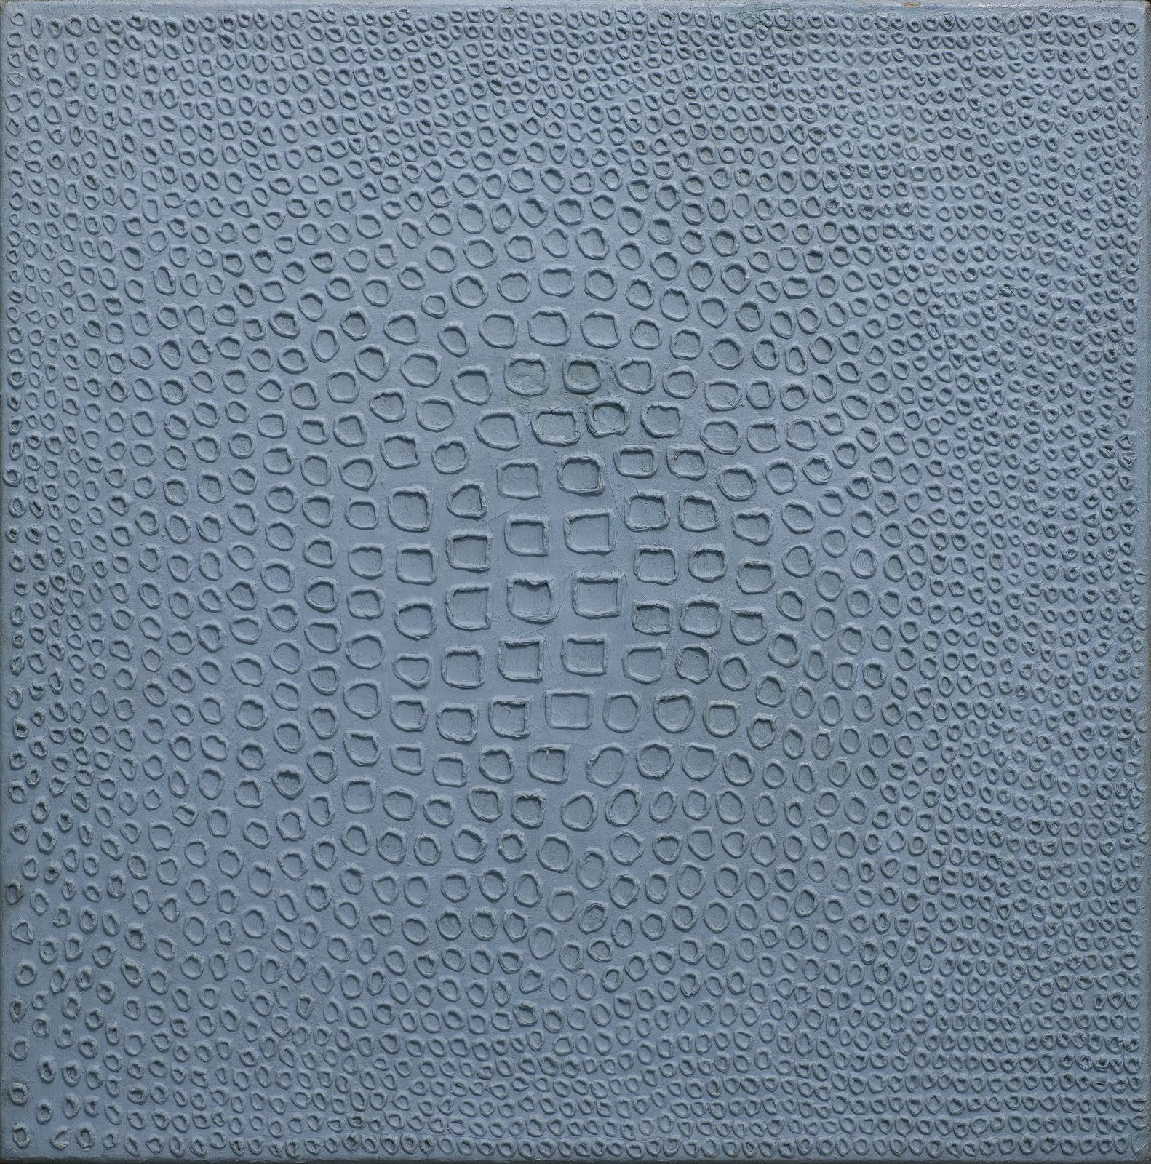
3. Władysław Strzemiński, Unist composition, 1931
http://3.bp.blogspot.com/_A15vz2_bcTg/TO5XQ4Ev1pI/AAAAAAAAEEI/xMyAwkL9L4Q/s1600/Wladyslaw_Strzeminski_Kompozycja_Unistyczna_14_1934_ol._.jpg&ir=http://artbazaar.blogspot.com/2010/11/powidoki-zycia-wadysaw-strzeminski-i.html&ig=http://t2.gstatic.com/images?q=tbn:ANd9GcTpYWz59qaVipe62Ff0fcsFFtQtxwnmGmW8FLVaQdba3Q9ppyD_tQWyg_GX0g&h=1600&w=1582&q=Wladyslaw+Strzeminski&babsrc=TB_ss

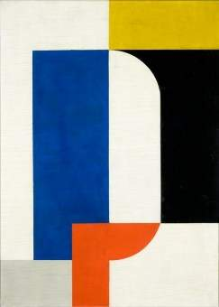
4. Henryk Stażewski, Composition, c. 1929-30, Museum of Art, Łódź
http://kultura.wp.pl/title,Henryk-Stazewski-1894-1988-Zmienny-konsekwentny,wid,9973052,wiadomosc.html

